**DIGITAL THERMOMETER USING ATMEGA32**

**REPORT:**

**ABOUT THIS PROJECT:**

This project is a simple thermometer which is easy to use and provides accurate results.

1)When the temperature is more than 35 degree celsius, the green led glows.

2)When the temperature is less than 35 degree celsius, the red led glows.

3)The 10K ohm potentiometer is used to set contrast of 16x2 LCD screen.

The main component used here is the temperature sensor (LM35).

**INTRODUCTION:**

A thermometer is a device that [measures temperature](https://en.wikipedia.org/wiki/Temperature_measurement) or a [temperature gradient](https://en.wikipedia.org/wiki/Temperature_gradient) (the degree of hotness or coldness of an object).

A thermometer has two important elements:

(1) a temperature sensor (e.g. the bulb of a [mercury-in-glass thermometer](https://en.wikipedia.org/wiki/Mercury-in-glass_thermometer) or the pyrometric sensor in an [infrared thermometer](https://en.wikipedia.org/wiki/Infrared_thermometer)) in which some change occurs with a change in temperature;

(2) some means of converting this change into a numerical value (e.g. the visible scale that is marked on a mercury-in-glass thermometer or the digital readout on an infrared model).

Thermometers are widely used in technology and industry to monitor processes, in [meteorology](https://en.wikipedia.org/wiki/Meteorology), in medicine, and in scientific research..

**DIGITAL THERMOMETER:**

A digital thermometer is used to verify a smart temperature transmitter under flowing conditions and a successful calibration of the smart temperature transmitter. Portable electronic thermometers (PETs) are designed to measure temperature in a RTD-type thermowell using a thermistor or RTD probe.

The LM35 digital thermometer converts temperature sensitive current to digital, transmits that on demand through a protocol, while optionally powering all the circuitry from busts of voltage made present on one wire between packets.

Measurements are available over an operating range of -55°C to +125°C and spec'd accurate to ±0.5°C over the range of -10°C to +85°C. The device has a maximum reporting resolution of 1/16°C.

Experience shows a reporting resolution eight times that of the expected accuracy to be justified as measurements are highly repeatable over short time periods and show uniform step rates when observing slow changes of large thermal masses.

Thermometers are useful apparatus being used since long time for temperature measurement. In this project we have made an ATmega32 based digital thermometer to display the current ambient temperature on a 16x2 LCD unit in real time . It can be deployed in houses, offices, industries etc. to measure the temperature. We can divide this **ATmega32 based thermometer** into three sections - The first section senses the temperature by using [temperature sensor LM35](https://circuitdigest.com/tags/lm35), second section converts the temperature value into a suitable numbers in Celsius scale which is done by ATmega32, and last part of system displays temperature on [16x2 LCD](https://circuitdigest.com/article/16x2-lcd-display-module-pinout-datasheet)..

In this **digital temperature sensor with ATmega32**, ATMEGA32 is used to control the whole process. An LM35 temperature sensor is used for sensing environment temperature which gives 1 degree temperature on every 10mV change at its output pin. You can easily check it with voltmeter by connecting Vcc at pin 1 and Ground at pin 3 and output voltage at pin 2 of LM35 sensor. For an example if the output voltage of LM35 sensor is 250m volt, that means the temperature is around 25 degree Celsius.

ATMEGA 32 reads output voltage of temperature sensor by using Analog pin and performs the calculation to convert this Analog value to a digital value of current temperature. After calculations ATMEGA32 sends these calculations or temperature to 16x2 LCD unit by using appropriate commands of LCD.

**COMPONENTS USED:**

* ATMEGA 32
* LCD
* LM 35
* CAPACITORS
* FIXED VOLTAGE
* Connecting wires

**SOFTWARE USED:**

* SimulIDE

**ATMEGA 32:**

The AVR microController is based on the advanced Reduced Instruction Set Computer (RISC) architecture. ATmega32 microController is a low power CMOS technology based controller. Due to RISC architecture AVR microcontroller can execute 1 million of instructions per second if cycle frequency is 1 MHz provided by crystal oscillator.

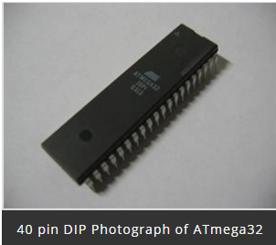

**Key Features:**

Consider some general features of ATmega32 microcontroller is:-

* 2 Kilo bytes of internal Static RAM
* 32 X 8 general working purpose registers
* 32 Kilo bytes of in system self programmable flash program memory.
* 1024 bytes EEPROM
* Programmable serial USART
* 8 Channel, 10 bit ADC
* One 16-bit timer/counter with separate prescaler, compare mode and capture mode.
* 32 programmable I/O lines
* In system programming by on-chip boot program
* Master/slave SPI serial interface
* 4 PWM channels
* Programmable watch dog timer with separate on-chip oscillator

**ATmega32 Microcontroller Pin**

**Diagram**

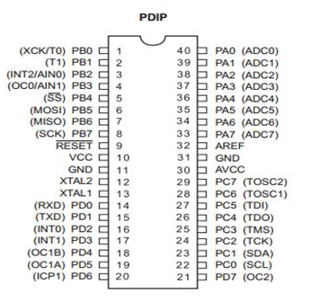

**LCD 16 X2**

**LCD (16 X 2)**

An electronic device that is used to display data and the message is known as LCD 16×2. As the name suggests, it includes 16 Columns & 2 Rows so it can display 32 characters (16×2=32) in total & every character will be made with 5×8 (40) Pixel Dots. So the total pixels within this LCD can be calculated as 32 x 40 otherwise 1280 pixels.

16 X2 displays mostly depend on multi-segment LEDs. There are different types of displays available in the market with different combinations such as 8×2, 8×1, 16×1, and 10×2, however, the LCD 16×2 is broadly used in devices, DIY circuits, electronic projects due to less cost, programmable friendly & simple to access.

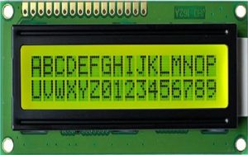

### LCD 16X2 Pin Configuration:

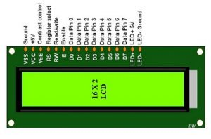

**LM35:**

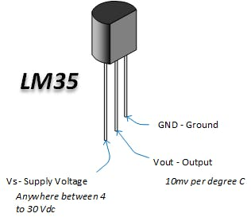An LM35 temperature sensor is an integrated circuit that generates an analog output signal equivalent to the instantaneous temperature.

LM35 is a temperature sensor that provides analog signal as its output which is linearly proportional to the temperature in degree celsius.

LM35 has three pins:

PIN 1 : Vcc, it is the input pin (5v)

PIN 2 : Vout, we get output (it should be connected to the analog pin of arduino)

PIN 3 : GND, it is used for ground

**SOFTWARE USED:**

**SimulIDE**

SimulIDE is a simple real time electronic circuit simulator, intended for hobbyist or students to learn and experiment with simple electronic circuits and microcontrollers, supporting PIC, AVR and Arduino.  
  
This is not an accurate simulator for circuit analysis, it aims to be fast, simple and easy to use, this means simple and not very accurate electronic models and limited features.

Simplicity and ease of use are the key features of this simulator.  
You can create, simulate and interact with your circuits within minutes, just drag components from the list, drop into the circuit, connect them and push power button to see how it works.  
  
SimulIDE also features a code Editor and Debugger for GcBasic, Arduino, PIC asm and AVR asm. It is still in it's firsts stages of development, with basic functionalities, but it is possible to write, compile and basic debugging with breakpoints, watch registers and global variables.



**Block diagram:**

**LCD 16 X 2**

ATMEGA32

**LM-35**

**CIRCUIT DIAGRAM:**

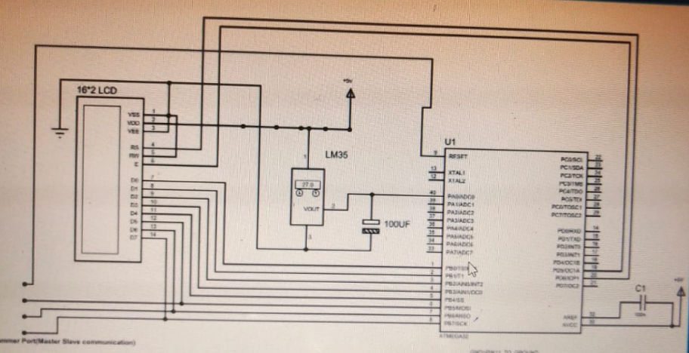

**CODE:**

**#ifndef __AVR_ATmega32__**

**#define __AVR_ATmega32__**

**#endif**

**#include <avr/io.h>**

**#define F_CPU 1000000**

**#include <util/delay.h>**

**#include <stdlib.h>**

**#define enable 5**

**#define registerselection 6**

**void send_a_command(unsigned char command);**

**void send_a_character(unsigned char character);**

**void send_a_string(char *string_of_characters);**

**int main(void)**

**{**

**DDRB = 0xFF;**

**DDRA = 0;**

**DDRD = 0xFF;**

**_delay_ms(50);**

**ADMUX |=(1<<REFS0)|(1<<REFS1);**

**ADCSRA |=(1<<ADEN)|(1<<ADATE)|(1<<ADPS0)|(1<<ADPS1)|(1<<ADPS2);**

**int16_t COUNTA = 0;**

**char SHOWA [3];**

**send_a_command(0x01); //Clear Screen 0x01 = 00000001**

**_delay_ms(50);**

**send_a_command(0x38);**

**_delay_ms(50);**

**send_a_command(0b00001111);**

**_delay_ms(50);**

**ADCSRA |=(1<<ADSC);**

**while(1)**

**{**

**COUNTA = ADC/4;**

**send_a_string ("OM SAI RAM");**

**send_a_command(0x80 + 0x40 + 0);**

**send_a_string ("Temp(C)=");**

**send_a_command(0x80 + 0x40 + 8);**

**itoa(COUNTA,SHOWA,10);**

**send_a_string(SHOWA);**

**send_a_string (" ");**

**send_a_command(0x80 + 0);**

**}**

**}**

**void send_a_command(unsigned char command)**

**{**

**PORTB = command;**

**PORTD &= ~ (1<<registerselection);**

**PORTD |= 1<<enable;**

**_delay_ms(20);**

**PORTD &= ~1<<enable;**

**PORTB = 0;**

**}**

**void send_a_character(unsigned char character)**

**{**

**PORTB = character;**

**PORTD |= 1<<registerselection;**

**PORTD |= 1<<enable;**

**_delay_ms(20);**

**PORTD &= ~1<<enable;**

**PORTB = 0;**

**}**

**void send_a_string(char *string_of_characters)**

**{**

**while(*string_of_characters > 0)**

**{**

**send_a_character(*string_of_characters++);**

**}**

**}**

**ADVANTAGES :**

* Temperatures may be read quickly and accurately using digital thermometers.
* They’re small and portable, and you can even keep the thermometer in your backpack.
* It’s simple to read the display.
* A digital thermometer is reasonably priced.
* They do not need any particular care.

**Disadvantages of digital thermometers:**

* Digital thermometers have the disadvantage of having dead batteries.
* Submerging a conventional thermometer in warm, soapy water is simple, but doing it with a digital thermometer is more complicated.
* Some digital thermometers are more accurate than others.
* When compared to rectal or oral thermometer readings, these thermometers might have a one or two-degree discrepancy.